AN LAC SEAFOOD CO., LTD. (HK216)
No. 38, 2A Street, Hung Vuong South – Tran Van Kieu North Residential Area, An Lac Ward, Binh Tan District, Hochiminh City, Vietnam.
STATEMENT
No.: 10/ALC/ 2011

TO.: SHING YUEH INTERNATIONAL CO., LTD.

DATE | INVOICE NO. | AWB | TOTAL
21 MAR. | 026/ALC | 695 3323 8306 | 7,992.79
22 MAR. | 027/ALC | 695 3323 9275 | 8,021.73
TOTAL |  |  | 16,014.52
18 MAR.  22 MAR. | 1,471.30 Kg  1,048.00 Kg  2,519.30 Kg x 0,50 USD |  | - 1,259.65
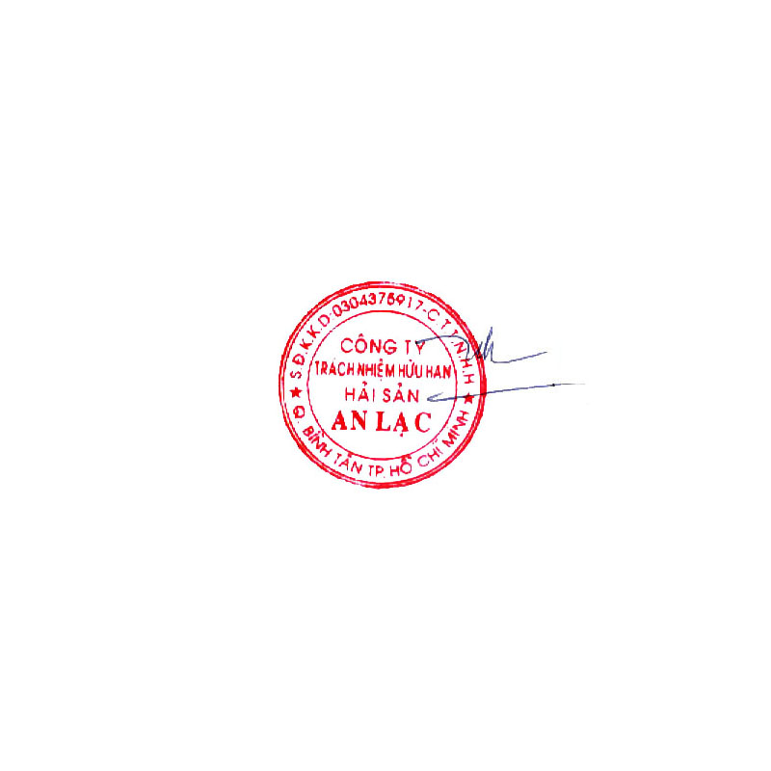  DAMAGE SHING YUEH MUST TRANSFER TO AN LAC |  |  | 3,418.65
GRAND TOTAL |  |  | USD 18,173.52
Says: US DOLLARS Eighteen Thousand One Hundred Seventy – Three And Fifty – Two Cents Only.
AN LAC SEAFOOD CO., LTD.
Account No. : 1402 1485 100 3419
Name Of Bank : EXIMBANK, DISTRICT 4 BRANCH, HOCHIMINH CITY, VIETNAM.
SWIFT : EBVIVNVXQ04
AN LAC SEAFOOD CO., LTD.

Leâ Thị Hoa

